Project Design Phase-II
Data Flow Diagram & User Stories

Date | 19 February 2026
Team ID | LTVIP2026TMIDS66455
Project Name | Visualization Tool for Electric Vehicle Charge and Range Analysis
Maximum Marks | 4 Marks

Data Flow Diagrams:
A Data Flow Diagram (DFD) is a traditional visual representation of the information flows within a system. A neat and clear DFD can depict the right amount of the system requirement graphically. It shows how data enters and leaves the system, what changes the information, and where data is stored.
Example: DFD Level 0 (Industry Standard)
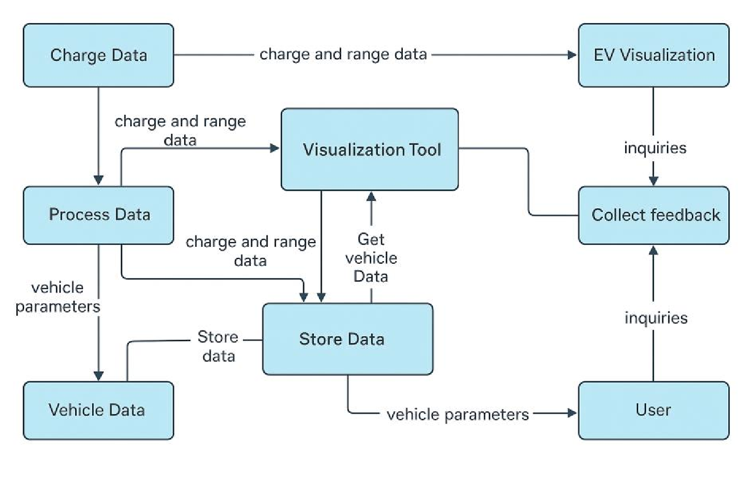
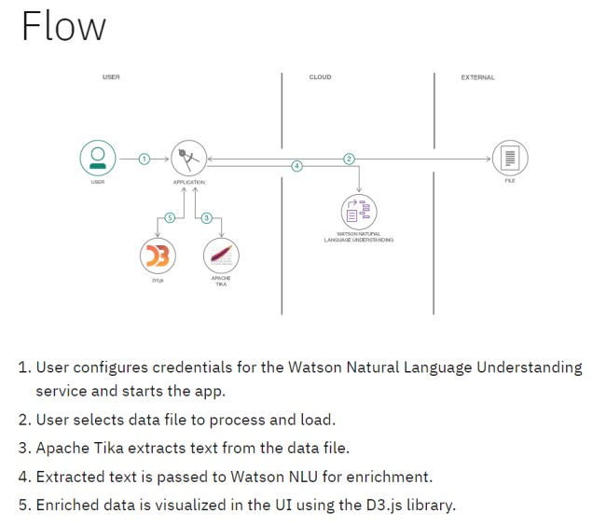
Example: (Simplified)

User Stories
Use the below template to list all the user stories for the product.
User Type | Functional  Requirement  (Epic) | User Story  Number | User Story / Task | Acceptance criteria | Priority | Release
\EV Owner (Mobile user) | Account  Management | USN-1 | As an EV user, I want to register and log in to the app to securely access personalized features | User can create an account and sign in using valid credentials | High | Sprint-1
 | Map Visualization | USN-2 | As a user, I want to view a map showing nearby charging stations and range zones | Map loads with charging station icons and vehicle range overlay | High | Sprint-1
 | Vehicle Charge Analysis | USN-3 | As a user, I want to input my vehicle’s battery level and get real-time range estimates | System provides accurate range estimates based on battery and driving data | Low | Sprint-2
 | Charging History | USN-4 | As a user, I want to view my previous charging sessions and performance reports | App displays historical charts and statistics about past charges | Medium | Sprint-2
Admin | Data  Management | USN-5 | As an admin, I want to upload and manage station data across different locations | Admin panel shows options to add/update station information | High | Sprint-1
 | User Monitoring | USN-6 | As an admin, I want to monitor system usage and user activity for improvement tracking | Dashboard reports include  session logs and activity  summaries | Medium | Sprint-3
Data Analyst | Reporting Module | USN-7 | As an analyst, I want to generate customized reports based on station usage and range patterns | As an analyst, I want to generate customized reports based on station usage and range patterns | Medium | Sprint-3
Guest User | Demo Access | USN-8 | As a guest, I want to explore the tool in demo mode without signing up | Demo mode provides limited but working sample visualizations | Low | Sprint-2

